ASC Tutorial Center Database
Person( SystemID: int, FirstName: string, LastName: string, Email: string, PhoneNum: int, UserName: string, Password: string)
Managers(DateHired: yyyy/mm/dd, SystemID)
SystemID is FK referencing Person.SystemID
Student( PreferredLanguage: string, SystemID) )
SystemID is FK referencing Person.SystemID
Tutors(DateHired: yyyy/mm/dd, ManagedBy: int, SystemID)
ManagedBy is FK referencing Manager.SystemID,
SystemID is FK referencing Student.SystemID.
SubjectsOffered(SubjectID: int, SubjectName: string, TutorCount: int (derived))
TutorCount is derived attribute calculated by counting rows in the expertise table
Expertise( YearsOfExperience: int, SystemID, SubjectID)
SystemID is FK referencing Tutor.SystemID,
SubjectID is FK referencing SubjectsOffered.SubjectID
Session(SessionID: int, Date: yyyy/mm/dd, SessionTime: time, Location: string, StudLim: int, SubjectID, SystemID, LanguageID)
SubjectID is FK referencing SubjectsOffered.SubjectID,
SystemID is FK referencing Tutor.SystemID,
LanguageID is FK referencing AvailableLanguage.LanguageID
Attend ( DateReg: yyyy/mm/dd, Status: string, SystemID, SessionID)
SessionID is FK referencing Session.SessionID,
SystemID is FK Student.SystemID
AvailableLanguage ( LanguageID: int, Language: string)
Fluency( LanguageID, SystemID, Fluent: string)
LanguageID is FK referencing AvailableLanguage.LanguageID,
SystemID is FK referencing Tutor.SystemID

Notes:
- We can change the names of the attributes; I just wanted them to be clear to understand right now if you look over it without being able to ask clarifying questions.
- Location – online or in person
Questions
- Should we include students’ year (freshman, sophomore etc or year 1, year 2.)?
- Would adding a topic to subjects be a good idea? (Future work-related question. We will use this in our presentation for the end when he wants us to discuss what we would add if we had more time)
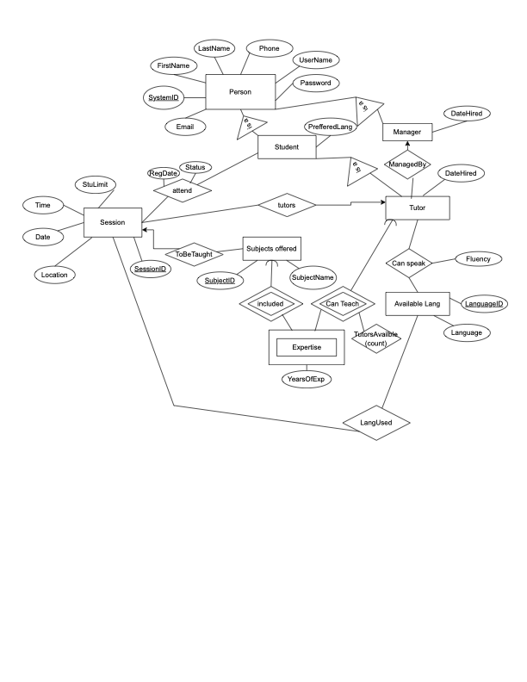

Sample Data:
Person
(1, 'James', 'Smith', 'jsmith@example.com', 5551011, 'jsmith', 'pass123'),
(2, 'Mary', 'Johnson', 'mjohnson@example.com', 5551012, 'mjohnson', 'pass456),
(3, 'Michael', 'Jones', 'mjones@example.com', 5551013, 'mjones', 'pass789'),
(4, 'Patricia', 'Davis', 'pdavis@example.com', 5551014, 'pdavis', 'pass101'),
(5, 'John', 'Garcia', 'jgarcia@example.com', 5551015, 'jgarcia', 'pass111'),
(6, 'Jennifer', 'Anderson', 'janderson@example.com', 5551016, 'janderson', 'pass121),
(7, 'Robert', 'Taylor', 'rtaylor@example.com', 5551017, 'rtaylor', 'pass131'),
(8, 'Linda', 'Wilson', 'lwilson@example.com', 5551018, 'lwilson', 'pass141'),
(9, 'David', 'Brown', 'dbrown@example.com', 5551019, 'dbrown', 'pass151’),
(10, 'Elizabeth', 'Jackson', 'ejackson@example.com', 5551020, 'ejackson', 'pass161’),
(11, 'William', 'Miller', 'wmiller@example.com', 5551021, 'wmiller', 'pass171'),
(12, 'Barbara', 'Martin', 'bmartin@example.com', 5551022, 'bmartin', 'pass181');
Manager
(1, '2021-08-12'), -- James Smith
(2, '2020-05-03'), -- Mary Johnson
(4, '2022-01-17') -- Patricia Davis
Students
(3, 'English'), -- Jones Micheal
(5, 'Spanish'), -- John Garcia
(6, 'English'),-- Jenifer Anderson
(7, 'French'), -- Robert Taylor
(8, 'English'), -- Linda Wilson
(9, 'Spanish'), - David Brown
(10, 'English'), -- Elizabeth Jackson
(11, 'German'); -- William Miller
Tutor
(3, '2022-08-01', 1),
(6, '2023-01-15', 2),
(7, '2021-11-10', 1),
(9, '2022-03-22', 4),
(11, '2023-06-18', 2);
SubjectsOffered
(1, 'Math'),
(2, 'Biology'),
(3, 'Chemistry'),
(4, 'English Writing'),
(5, 'Computer Science');
Expertise
(3, 1, 2),
(3, 4, 1),
(6, 5, 3),
(7, 1, 4),
(9, 2, 1),
(11, 4, 2),
(11, 5, 3);
AvailableLanugage
(1, 'English'),
(2, 'Spanish'),
(3, 'French'),
(4, 'German');

Fluency
(1, 3, 'Yes'),
(1, 6, 'Yes'),
(3, 7, 'Yes'),
(2, 9, 'Yes'),
(1, 11, 'Yes'),
(4, 11, 'Yes');
Session
(1, '2024-11-01', '10:00:00', 'Room 101', 5, 1, 3, 1),
(2, '2024-11-02', '14:00:00', 'Online', 4, 5, 6, 1),
(3, '2024-11-03', '09:00:00', 'Room 303', 6, 2, 9, 2),
(4, '2024-11-04', '13:00:00', 'Online, 5, 4, 11, 1);
Attend
(5, 1, '2024-10-20', 'Registered'),
(8, 1, '2024-10-21', 'Attended'),
(10, 2, '2024-10-22', 'Attended'),
(9, 3, '2024-10-23', 'No-Show),
(6, 4, '2024-10-25', 'Registered'),
(3, 4, '2024-10-26', 'No-Show');

